Individual health sheet
To be completed by parents or all participants over 18 at the start of each scouting year and before camps.
The purpose of this sheet is to attain as much information as possible about you/your child in case of need. This sheet will help the leaders or caring staff as necessary. It is crucial that the information you provide is complete, correct and up to date at the time of the activities in question. Do not hesitate to add written or oral information for the leaders if you feel this is useful.
Identity of the participant:
Surname: Name:
Date of birth / matricule: Address:
Nr: Street :
Zip code: Town:
Phone / mobile phone : E-mail:
PLEASE ATTACH

- Photocopy of Social Security Card/ European health insurance card
- Vaccination card
Contact person(s) in case of emergency

1.Name, Address:
Family relation:
Phone / mobile phone E-mail:
2.Name, Address:
Family relation:
Phone / mobile phone E-mail:
Attending physician

1. Name, Address:
Phone / mobile phone E-mail:
2. Name, Address:
Phone / mobile phone E-mail:

Confidential information about the health of the participant:
Is the participant able to take part in the activities proposed? (Sports,excursions,games,swimming,etc.)

Reasons for non-participation:

Is there specific medical information that is important to know for the organisation of the activity/camp? (e.g.: heart problems, epilepsy, asthma, diabetes, car sickness, rheumatism, sleepwalking, skin conditions, physical or mental disability, etc.) Indicate the frequency and gravity of the condition and the actions to be taken for preventing and/or responding in case it materialises:

What illnesses or medical interventions has the participant suffered or undergone? (+ in what year)? (measles, appendicitis, etc.)

Are the participant’s tetanus injections in order? YES / NO Date of the last vaccine:
Does the participant have an allergy to certain substances or medication? YES / NO
If yes, which ones?
What are the symptoms?
Does he have to follow a particular diet? YES / NO If yes, which diet?

Other information regarding the participant, which you deem to be important (sleeping problems, nocturnal incontinence, physical or psychological problems, wears glasses or hearing aid, etc.):

Does the participant take medication? YES / NO If yes, which medication?
Which medication? | What dose? | When?
a
b
c

Is the participant able to take this medication autonomously? YES / NO
(We remind you that medication cannot be shared among participants)

Notes

a) The leaders have a first-aid kit at their disposal. If necessary or pending the arrival of a doctor, they can administer the medication below after careful consideration: Paracetamol, Reparil®, disinfectant (Cedium®), Fenistil®, Flamigel®.

b) “I authorise the local doctor to take the decisions he feels to be urgent and indispensable to ensure the good health of my child, even if this pertains to surgical interventions, if I cannot be contacted personally.”

c) The information contained in the medical file is confidential. As a consequence, the information on this file may only be disclosed to the consulted doctor or any other medical personnel.

d) The participant, or his legal representative in case of his minority, gives his consent to FNEL as to the transmission of this personal data in case of necessity to the medical personnel by signing the form at hand

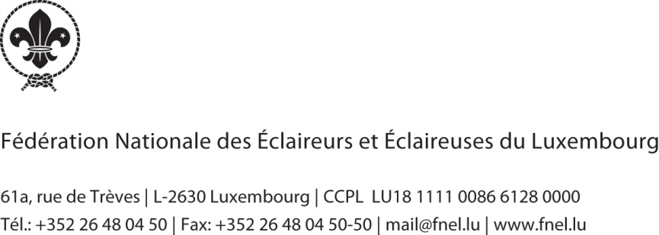
Date and signature :…………………………………………………………………..

