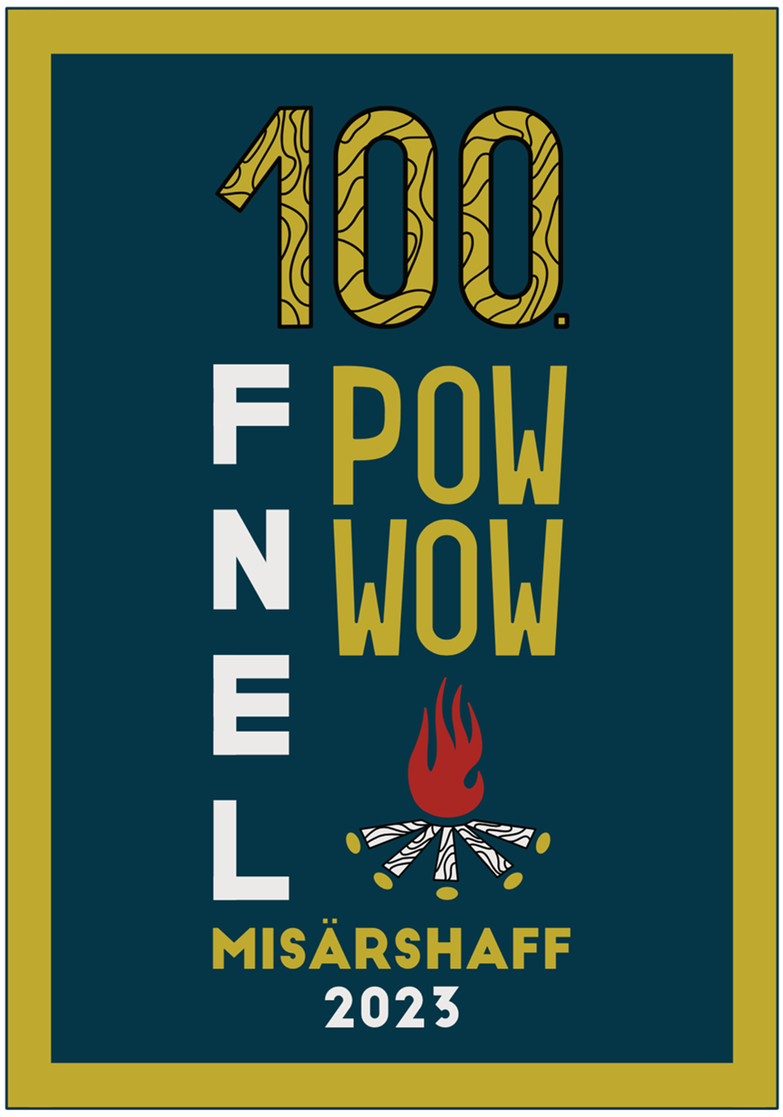
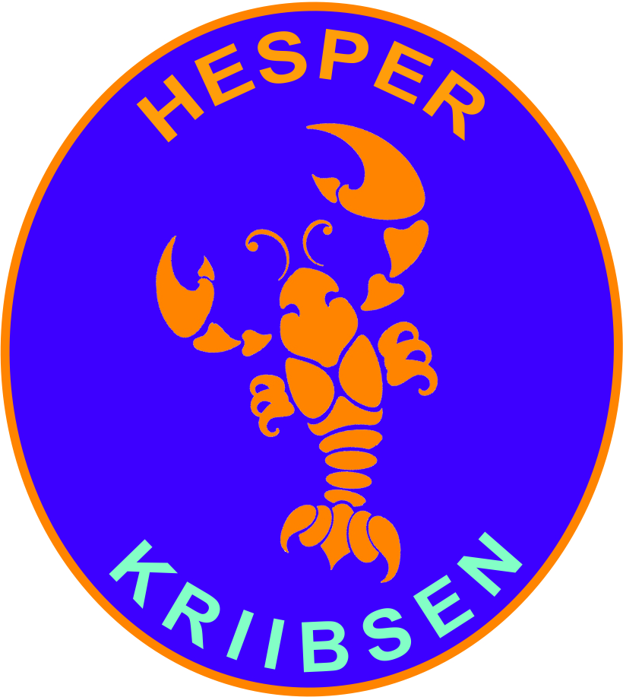
Invitation

Dear Beaver/Cub,

This year, on the 9th of June, the PowWow will be held again at the Misärshaff. All of the groups from the FNEL are invited and this year is very special, because it is the 100th Edition of the PowWow. We expect a lot of people joining from all over Luxembourg and we want you to be part of this special event as well! Here are some details:

Departure

The FNEL will organise busses to pick us up in Alzingen, departure time is around 08h00. Once the amount of inscriptions if known, we will get an exact time when we need to be at the pick up place.

Arrival

The end time of the PowWow is 16h00, after that we will take the organised bus back to Alzingen. This will take normally around 1h30, so count on an arrival time of 17h30. Like with the departure, as soon as the inscriptions are known, an exact time will be communicated.

What to bring along

- Uniform
- Scarf (Foulard)
- Water bottle (Bidon)
- Pic-nic

How to inscibe

Please fill out the form via this link: https://forms.gle/zCRxmxrRyFn69bhMA
Also, make a transfer of 10€ into the Hesper Kriibsen Account LU08 1111 7447 9933 0000
Please respect the delay of 08/06/2023!!
Lénks Patt,
Your Beavers/Cubs Cheffen

